**Week -1 Data Structures and Algorithms Mandatory HandsOn Solutions**

**Exercise 2: E-commerce Platform Search Function**

**Source Code:**

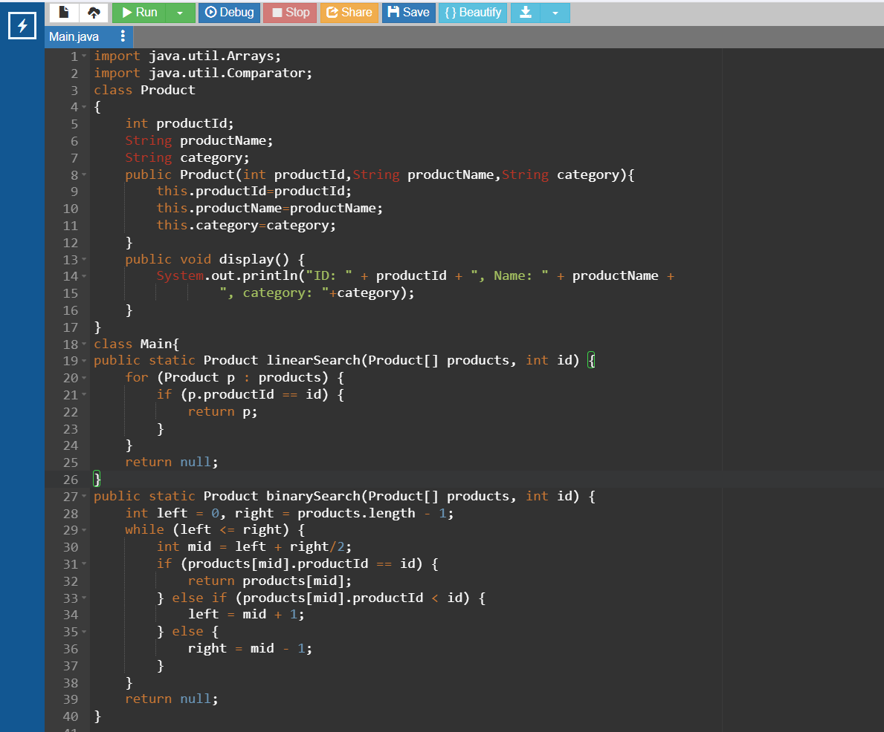

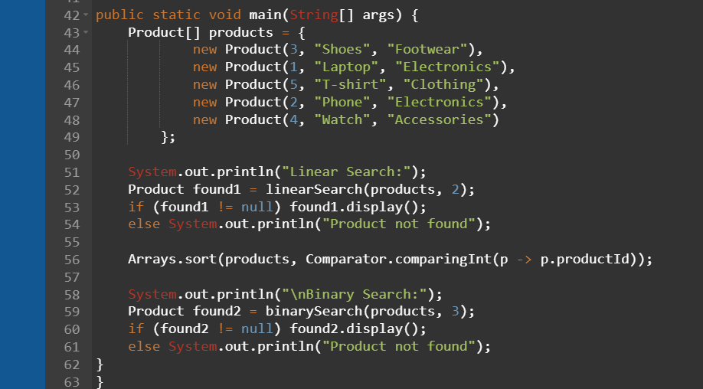

**Output:**

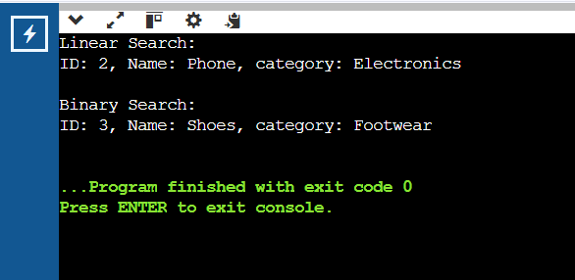

**Exercise 7: Financial Forecasting**

**Source Code:**

